Paul Stanton

CS 04605 – Advanced Web Programming

Assignment 10

For this assignment we need to modify the places page to allow us to add a new place and include a picture just like we have with register user.

To accomplish this first I will Setup the project:

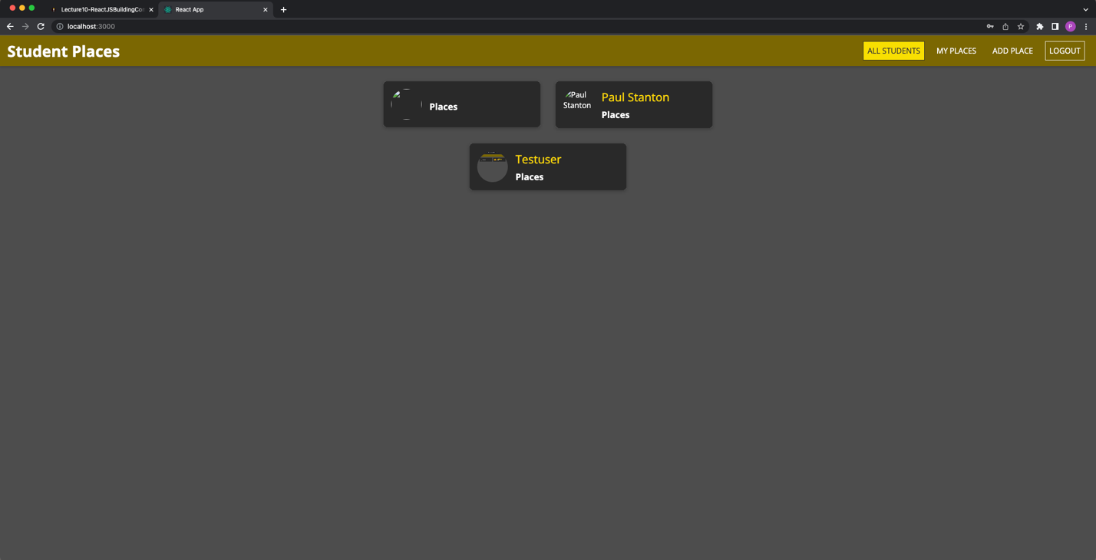

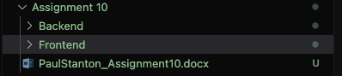

Then I will add in the ability to view places for a user which we did in Assignment 9. This will make it easier to validate my change:

Then I will modify the add place endpoint to take in a photo and save it like we do with register user.

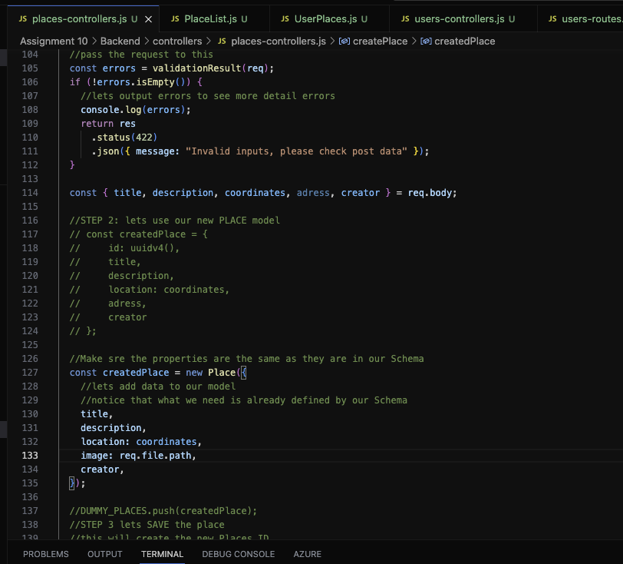

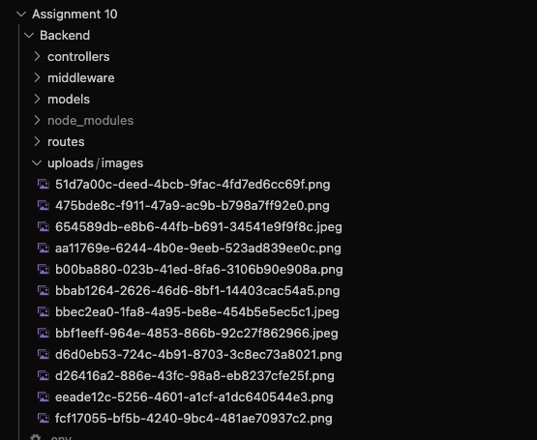

Then I will modify the front end to allow the user to select a photo and upload it to the endpoint. Currently I cannot pull the image down, but it is saved to the node project.

